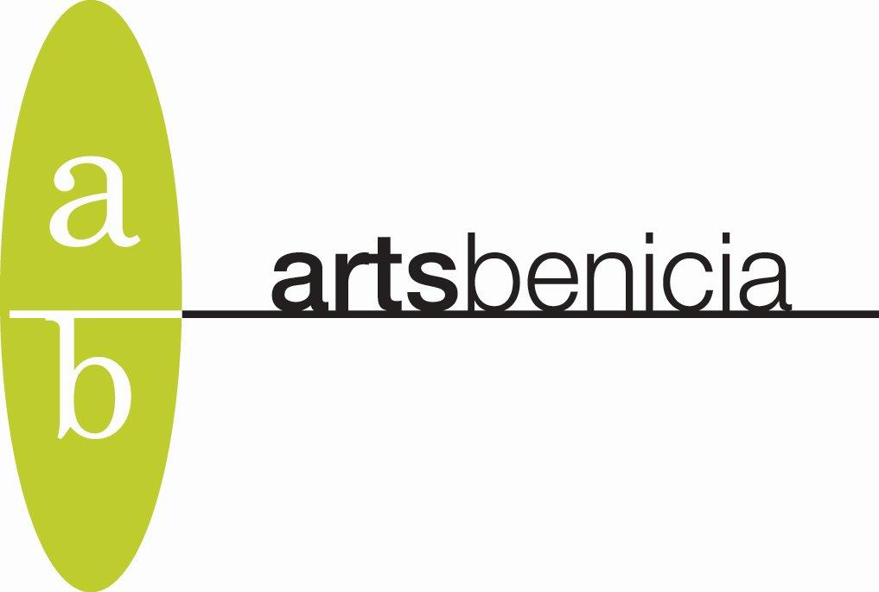

Young Printmakers Program Opportunity

Arts Benicia is offering a Young Printmakers Program in spring 2026. We are inviting letters of interest from persons 18 – 25 years of age who wish to study a range of printmaking techniques at Arts Benicia’s Printmaking Annex, located in the historic Arsenal District in Benicia. Scholarships will be awarded to approximately ten students, providing one to two weekly printmaking classes for three to four months, and occasional special classes with professional instructors.

To be considered for this opportunity, please send a one-page letter of interest to celeste@artsbenicia.org that includes:

- Name, age, and contact information
- Why you are interested in printmaking
- Your past or current art education experience
- Two references, their contact information, and your relationship to them

Arts Benicia is especially interested in providing this printmaking opportunity to persons from traditionally underserved communities in Solano County.

Arts Benicia Printmaking Workshop is a signature program of the organization. Established in 2001 by master printer Bill Harsh the program offers ongoing weekly printmaking classes and special, unique workshops year-round. Classes include etching, intaglio, monoprint, letterpress, and book arts. Lead teacher and Program Coordinator Ronna Leon studied directly with Bill Harsh, and she is highly skilled in printmaking techniques.

The Arts Benicia Young Printmakers Program is supported by a grant from the California Arts Council. We are grateful for their support.

